NTT DATA Corporation
100 City Square
Boston, MA 02129
Tel: +1 800 745 3263 Fax: +1 617 241 9507
Email: info@nttdata.com



Automate Web Development
Dynamic Web Page Builder
(White Paper for NTT Data Gold Club)

Hemasundar Reddy Katila
(Employee ID: 24287)

BMS Version 10.01
STATEMENT OF CONFIDENTIALITY / DISCLAIMER
This document is the property of NTT Data and is produced in response to your request. No part of this document shall be reproduced, stored in a retrieval system, or transmitted by any means, electronic, mechanical, photocopying, recording, or otherwise, to parties outside of your organization without prior written permission from NTT Data.
Table of Contents

1 About the Author(s)/Contributors 3
2 Introduction 4
3 Context 5
4 Topic-Solution 6
5 Conclusion 7
6 Glossary 8
7 References 9

About the Author(s)/Contributors

- Hemasundar Reddy Katila holds a Master’s degree in Computer Application from Vishvesvaraya Technological University, Belgaum, India.
- He has 72 months of IT experience, he brings a unique perspective to user experience design and web & app development. Each position he held has transmuted his skillset and goals towards forward-thinking technology.
- He is a multi-disciplinary UI Developer with a unique blend of both Interface Design and Develop lightweight mobile and high-end responsive web applications. His expertise includes rapid prototyping, UI development with WCAG standards.
- Providing Usability and User Experience expertise to support ongoing projects.
- Working with the Senior UI Architects on implementing functional requirements of various applications.
- Reviewing the code and optimizing it for better performance of web application.
- Developing JQuery plugins based on clients requirement.
- Browser and Usability Testing. Always keen on developing bug free, cross browser/backward compatible optimized code which is more efficient delivers high performance.
- Contributing in developing client specific Bootstrap. Testing including error checking, website load testing, browser compatibility and accessibility testing.
- Developed HTML wireframes/mock-ups as per business requirements and client needs. Created web layouts, logos and web images in Photoshop & slicing psd’s into HTML & CSS.
- Reviewed and evaluated color palettes, typography, compositions, deep cross browser debugging, fixing functional and alignment issues, website optimization, client side validation with proper message and uploading into web server.
- Coding, styling, testing of reusable JavaScript, CSS3, html5 widgets / libraries for complex UI controls
- Building web applications dynamically and solving complex technical problems with JavaScript, JQuery, Ajax and Firebug.

Introduction

Introduction
– An overview of what this whitepaper / technical paper addresses, provides executive summary
- Goals / Abstract –NTT DATA is handling lot of web based application, where we are always developing static web pages manually. It includes header, navigation, menus, forms, body content, footer, slides, and many sections. To reduced the manual web page design by this process.
- Target Audience – Resources who develop the static web pages for any type of projects.
- Organization – This tool is developed in such a way that the user experience resource can use this tool with the help of drag and drop options or the help of all auto generate header, navigation, menus, forms, body content, footer, slides, and many sections. When you develop websites, time is very much important. The more shortcuts you have in this tool and pre-made options you can use. It saves you hours of programming, allowing you to work on the actual website design.

Whitepaper / Technical Papers – Possible Areas

This process focuses on the improvement of static web page development including some functional requirement tool for the projects. The process reduces the development effort for a single static page from 60 minutes to 5 minutes.

Here’s why you’ll love using tool if you design websites. This tool is for everyone who wants to design any kind of web pages, no need of depth knowledge in web designing, who don’t have good knowledge in programming; they can also develop web pages. One can customize it later, if their requirement keeps on changing.

Tools and Technology used for this:

Technologies: HTML/HTML5, CSS/CSS3, Java, JavaScript, JQuery, JSON, Ajax
Tools: Photoshop, Notepad++/Sublime.

Context

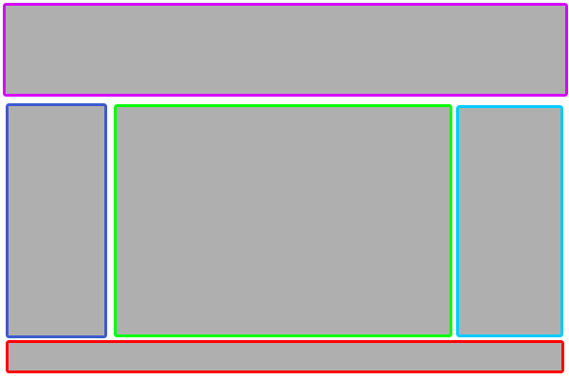

Static Page
This is a static page which has no functionalities in the page. The content of page which does not grow. It is completely static the places of content does not change. For this also our developers are taking some time to develop this. If we make it automate this then developers can easily reduce their time by using this online tool.

Web Page
Above shown image describes about normal static web page. Basic building blocks for all websites are header, navigator, sidebar, content and footer. Images, color palette, typography, content and functionalities may vary from one websites to another. End of the day they all are made with above mentioned blocks. So if we make these things as automatic or dynamic one could save web page development time and a non-developer can also utilize this tool.

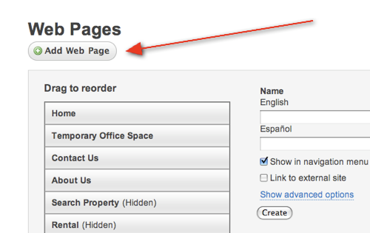

Dynamic Page
This is a dynamic page which has functionalities in the page. The content of page which can change any time as per requirement. It is completely dynamic the places of content and the functionality can change. For this changes our developers are taking more time to develop this. If we make it automate this then we can reduce the resources to make them engage in some other engagements. ????????????/

Dynamic Web Page builder saves time and resource so that we can utilize them for other productive work.
This online automate web Development tool will reduce our time as well as resources just because of this tool.

Topic-Solution
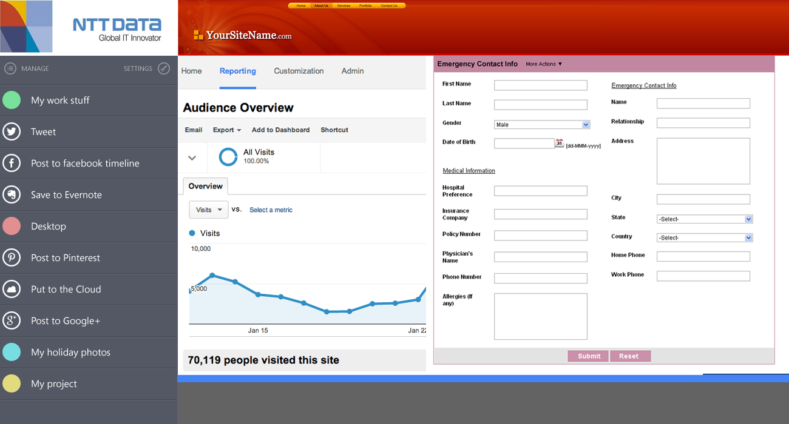

This method saves the developer‟s development time of 55 minutes for each static page. In the future, even if the client requires 100 static pages in a day, it can be delivered with 100% defect free on the same day for QA validation. Because when the static page is individually designed, any one of the property (Document Type, Placeholder, Position of the page, formula written for each placeholder variable, variable assigned for each static form) may be assigned wrongly. The only effort that the developer is going to put for this method is converting the word document into pdf, follow the naming convention and place the page in the server path.

This online tool includes all types of graphs, forms, header, footer, navigation, sliders, slideshows and so on. All types UI related components will be available in this tool. Just we need to to do just place the components in place based on clients requiremen.

Conclusion
This online tool saves the developer’s development time of 80% for each static page. In the future, even if the client requires more static and dynamic pages in a day, it can be delivered with 100% defect free on the same day for QA validation. Based on themes, does not matter what type of color combination and when the static pages is individually designed, any one of the property (Document Type, Placeholder, Position of the page, formula written for each placeholder variable, variable assigned for each static form) may be assigned wrongly. The only effort that the developer is going to put for this tool is drag and drop the components and place the right position.

Dynamic Web Page builder is an online webpage development tool which can be used by person who has zero programming background. There is no compulsion that user must know any web based programming language or scripts. This helps to build pages dynamically once user feeds required components for the webpage. I.e. if the user feeds header/footer, number of sidebars and the position of each component using this tool, he will get the corresponding HTML code in the same window and can utilized for further action This automatically generated code is well organized and follows W3c standard so that no need to validate it again. User will have the option of selecting themes, color palette, typography and customizing it. The only effort that the user is going to put for this tool is to drag and drop the components and place it in right position.

5.1 Advantages
- Reduce the developer time that is spent on manual processes of designing, coding, unit testing & peer reviewing.
- Increases the developer productivity and reduce errors with automated processes.
- Eliminate maintenance and support costs.
- Reduce the recourses and their time.
- It will support RWD and all types of devices like IPhone, Tablets and all.

- Reduces the implementation time that is spent on manual processes like designing, coding, unit testing & peer reviewing.
- Increases the developer’s productivity and reduces errors which occur due to automated processes.
- Eliminates maintenance and support costs.
- Any non-developer can make use of this tool.
- Since tool supports Responsive Web Designing, it will be used in all mobile environment as well.

5.2 Disadvantages
The static and dynamic pages created through this online automate web development tool may need more time to test, when we develop the this application.

Considering this online tool development as single project, serving multiple functionalities like dynamic code generation, code validation etc., implementation may be time consuming.

Glossary
RWD: Responsive Web Design
QA: Quality Assurance

References

- ACT Discretionary Projects

